## Declaration on Plagiarism

|  |  |
| --- | --- |
| **Name:** | Souradip Goswami |
| **Student Number:** | 19210273 |
| **Programme:** | DC836 MSc. In Computing |
| **Module Code:** | CA682 |
| **Assignment Title:** | Data Visualisation |
| **Submission Date:** | 13 Dec 2019 |
| **Module Coordinator:** | Dr Suzanne Little |

I declare that this material, which I now submit for assessment, is entirely my own work and has not been taken from the work of others, save and to the extent that such work has been cited and acknowledged within the text of my work. I understand that plagiarism, collusion, and copying are grave and serious offences in the university and accept the penalties that would be imposed should I engage in plagiarism, collusion or copying. I have read and understood the Assignment Regulations. I have identified and included the source of all facts, ideas, opinions, and viewpoints of others in the assignment references. Direct quotations from books, journal articles, internet sources, module text, or any other source whatsoever are acknowledged, and the source cited are identified in the assignment references. This assignment, or any part of it, has not been previously submitted by me or any other person for assessment on this or any other course of study.

I have read and understood the referencing guidelines found at <http://www.dcu.ie/info/regulations/plagiarism.shtml>, <https://www4.dcu.ie/students/az/plagiarism> and/or recommended in the assignment guidelines

Name: Souradip Goswami Date: 13th December 2019

**FIFA ranking changes from 2014 to 2018 and predicting the probable Best Eleven prior to World Cup 2018 Russia**

FIFA world cup is widely regarded as the biggest sporting event on Earth. The visualisations provided below aims to depict two interesting aspects:

* How the top 10 FIFA rankings had fluctuated from the end of 2014 FIFA World Cup to the beginning of 2018 FIFA World Cup.
* Predicting a best eleven based on the skillset possessed by different players.

The FIFA ranking fluctuations have been depicted using a racing bar chart which clearly points out that prior to the commencement of the FIFA World Cup in Russia, the five strongest teams were Germany, Brazil, Belgium, Portugal and Argentina. So purely based on the ranking points, these were the teams that were clear favourites. But as we all know the performance on a given day is all that matters in sport, and France were rightfully crowned the champions.

The best 11 eleven is predicted based on 34 attributes that a player possesses like ball control, accuracy, finishing to name a few. The formation is taken as 4-3-3 which signifies 4 defenders, 3 midfielders and 3 forwards along with a goalkeeper. The teams might change with a change in formation.

1. **Dataset**

There are two different sets of data that have been used: one to show the ranking changes and other for finding out the best eleven. Please find below the different aspects of the two datasets that have been used:

* **Dataset to predict the best eleven**

The dataset has been retrieved from Kaggle and it consists of 53 columns and 18k rows. Each row consists of name of the players along with different information regarding them like age, nationality, clubs they play for, current image of the players, their wages, release clause, current market value. There are around 34 attributes for each player as well like skill, position, crossing, finishing, heading accuracy, short passing, volleys, dribbling, long passing, acceleration etc. All the attributes are numeric i.e. each player has been assigned a score for each of the attribute. A high value for a particular attribute signifies that the player is highly skilled in that area.

* **Dataset to show the ranking changes between 2014 and 2018 World Cup**

The dataset has been retrieved from Kaggle and it consists of 16 columns and 57k rows. Each row consists of the country name, country abbreviations, total ranking points, previous points, rank change, average points of the last few years and the current ranking date. The dataset consists of month-wise rankings of each and every team starting from 1993 till 2018.

**Data Exploration, Processing, Cleaning and/or Integration**

The two datasets that have been used required different types of cleaning and processing to make it ready for visualisation. Please find below the details of exploration, processing and cleaning of the datasets:

* **Dataset to predict the best eleven**
  + - The exploration and cleaning of the dataset has been done using Python.
    - The initial dataset had 53 columns and 18k rows. The final dataset has 11 rows- one for each player and 8 columns. The columns are name, player image, nationality, flag, club, club logo, position and a combined stat containing nationality, club and jersey number together.
    - The best 11 has 1 goalkeeper, 4 defenders, 3 midfielders and 3 forwards.
    - To find out the best eleven three weights have been assigned having values 5, 4 and 3.
    - While finding the best goalkeeper, weightage 5 is multiplied with the attributes like GKDiving, GKReflexes etc as they are of prime importance for a goalkeeper, 4 is multiplied with attributes of slightly less significance and 3 with those having least significance.
    - The player having the highest sum of all the attributes multiplied by their weight has been selected.
    - Similarly, the defenders, midfielders and forwards have been selected by using the right attribute and assigning the correct weights to each of them.
    - All the columns that are not required to visualize the data has been removed. This data is fed to the visualization tool.
* **Dataset to show the ranking changes between 2014 and 2018 World Cup**
  + - The initial dataset had 16 columns and 57k rows and consisted of the ranking points of each country from August 1993 till June 2018.
    - All the rows till August 2014 has been deleted from the csv file itself as the ranking fluctuations are shown post World Cup 2014 and prior to World Cup 2018.
    - The next phase of cleaning and processing has been done using python.
    - The final output that was required to create the racing bar chart was: (a) unique country names as row headings, (b) unique ranking date as column headings along with the correct ranking points for a row-column combination.
    - Therefore, the unnecessary columns were deleted and only country name, country logo, total ranking points and ranking date were kept.
    - Then a crosstab function was performed in python to get the necessary rows, columns and the required values for a particular row-column combination.

The resultant datasets have been used to create the final visualization using the flourish application.

**Visualisation**

* **Ranking changes from August 2014 till June 2018**

The below screenshot shows an instance of the video of ranking changes from September 2014 till June 2018. The Racing Bar Chart has been made using “app. flourish. Studio”. The background is a football stadium at night and each bar signifies the ranking points of a particular country (country name provided on each bar) arranged from highest to lowest. The country flag is present on the left-hand side of every bars. All the bars are coloured yellow with a diminished brightness thereby ensuring less stress to the eye without compromising on the information that it tries to provide. This type of moving bar chart is the easiest and most suitable way to show the changes in rankings.

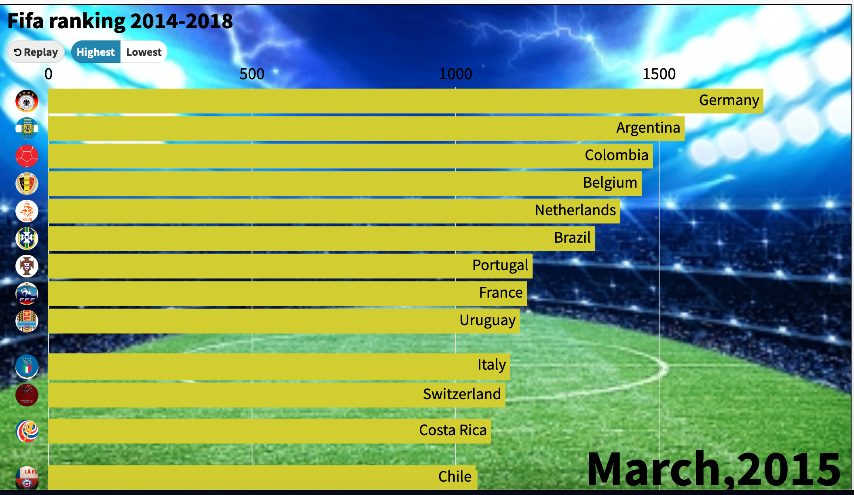

* **Best 11 prior to FIFA World Cup 2018**

The screenshot provided below shows the best eleven players that would be playing in World Cup 2018 based on 4-3-3 formation. Visualization has been made using a typical background colour of green signifying the football pitch. The players along with their current images are displayed on the field according to their positions based on the formation that has been chosen. The surrounding is a single dark colour which enhances the visual quality as well as makes the user focus only on the pitch which contains all the important information. The visualization is made more informative by making it interactive i.e. on taking the mouse over each player one can obtain the information about their nationality, the club they play for and their jersey numbers. The header text has a simple white font and the name of the players are in black making the visualization easy in the eye.



**Conclusion**

The primary focus of the first visualization is to show the ranking changes from 2014 till 2018 (before the world cup) and provide an overview about which teams are strong and have performed well on a consistent basis for the last four years. The second visualization i.e. the probable eleven is made on some personal assumptions and shows the strongest team that can take the field provided the formation is 4-3-3.

However, there are certain aspects that could have been improved for sure. These are:

* The football pitch for the best eleven clearly looks quite artificial. A background with a real football turf would have made the visualization much better. But I was unable to achieve that technically.
* The racing bar chart does not have an option to play the video faster or slower. Some end user might find the video a bit slow while others may find it a bit fast. Therefore, it would have been nice if there was an option to control the speed.
* The interactivity in the best eleven visualization is quite an amateur one and a lot of things could have been improved. One of the basic is that the picture of the player should have enlarged when the cursor is on them. The information provided are known to almost everyone, so some other facts like number of goals scored by a forward in the past year or number of assists made by the midfielders would have been more useful.

**References**

* **https://www.kaggle.com** – Source of the datasets.
* **https://www.youtube.com/watch?v=cy26iRuZlAY** – Racing bar chart example
* **https://www.youtube.com/watch?v=hy-8Tc1h-1s&t=448s** – Best Eleven example
* **https://pbpython.com/pandas-crosstab.html** - Python Crosstab function